Assignemnt5 - Hierarchical Clustering

Pranay Kumar Kodeboyina

2023-04-16

# importing the libraries and including knitr package  
library(knitr)  
# importing the libraries and including dendextend package  
library(dendextend)

##   
## ---------------------  
## Welcome to dendextend version 1.16.0  
## Type citation('dendextend') for how to cite the package.  
##   
## Type browseVignettes(package = 'dendextend') for the package vignette.  
## The github page is: https://github.com/talgalili/dendextend/  
##   
## Suggestions and bug-reports can be submitted at: https://github.com/talgalili/dendextend/issues  
## You may ask questions at stackoverflow, use the r and dendextend tags:   
## https://stackoverflow.com/questions/tagged/dendextend  
##   
## To suppress this message use: suppressPackageStartupMessages(library(dendextend))  
## ---------------------

##   
## Attaching package: 'dendextend'

## The following object is masked from 'package:stats':  
##   
## cutree

# importing the libraries and including factoextra package  
library(factoextra)

## Loading required package: ggplot2

## Welcome! Want to learn more? See two factoextra-related books at https://goo.gl/ve3WBa

# importing the libraries and including readr package  
library(readr)  
# importing the libraries and including cluster package  
library(cluster)  
# importing the libraries and including caret package  
library(caret)

## Loading required package: lattice

#Including the library read r. to read the data set   
library(readr)  
#Extracting the current working directory  
getwd()

## [1] "/Users/kodeboyina/Documents/Kent State/Sem1/Fundamentals of ML/Assignment5"

#setting seed  
set.seed(123)  
  
#Loading Cereals csv data Import the data set into R  
cereals <- read.csv("data/Cereals.csv", header = TRUE, sep = ",", stringsAsFactors = FALSE)  
  
#viewing the data frame to identify the numeric columns  
View(cereals)  
  
#Observing the first 10 observations of the data set  
head(cereals, n=10L)

## name mfr type calories protein fat sodium fiber carbo  
## 1 100%_Bran N C 70 4 1 130 10.0 5.0  
## 2 100%_Natural_Bran Q C 120 3 5 15 2.0 8.0  
## 3 All-Bran K C 70 4 1 260 9.0 7.0  
## 4 All-Bran_with_Extra_Fiber K C 50 4 0 140 14.0 8.0  
## 5 Almond_Delight R C 110 2 2 200 1.0 14.0  
## 6 Apple_Cinnamon_Cheerios G C 110 2 2 180 1.5 10.5  
## 7 Apple_Jacks K C 110 2 0 125 1.0 11.0  
## 8 Basic_4 G C 130 3 2 210 2.0 18.0  
## 9 Bran_Chex R C 90 2 1 200 4.0 15.0  
## 10 Bran_Flakes P C 90 3 0 210 5.0 13.0  
## sugars potass vitamins shelf weight cups rating  
## 1 6 280 25 3 1.00 0.33 68.40297  
## 2 8 135 0 3 1.00 1.00 33.98368  
## 3 5 320 25 3 1.00 0.33 59.42551  
## 4 0 330 25 3 1.00 0.50 93.70491  
## 5 8 NA 25 3 1.00 0.75 34.38484  
## 6 10 70 25 1 1.00 0.75 29.50954  
## 7 14 30 25 2 1.00 1.00 33.17409  
## 8 8 100 25 3 1.33 0.75 37.03856  
## 9 6 125 25 1 1.00 0.67 49.12025  
## 10 5 190 25 3 1.00 0.67 53.31381

# Set row names to the Cereals column  
rownames(cereals) <- cereals[,1]  
  
#Returns the original vector of column names in their original order  
t(t(names(cereals)))

## [,1]   
## [1,] "name"   
## [2,] "mfr"   
## [3,] "type"   
## [4,] "calories"  
## [5,] "protein"   
## [6,] "fat"   
## [7,] "sodium"   
## [8,] "fiber"   
## [9,] "carbo"   
## [10,] "sugars"   
## [11,] "potass"   
## [12,] "vitamins"  
## [13,] "shelf"   
## [14,] "weight"   
## [15,] "cups"   
## [16,] "rating"

#Only identifying the numeric data from the data frame columns 4 to 16  
cereals_df <- data.frame(cereals[,4:16])  
  
# Copy the original data to data frame two to perform normalization and fitting data set and scaling for a clustering technique  
cereals_df1 <- na.omit(cereals_df)  
  
# Using omit function to remove the NA values from the data set.  
cereals_df2 <- scale(cereals_df1)  
  
#The total number of observations after ommiting the NA data are 74 observations(3 omitted dute to empty data)  
head(cereals_df2)

## calories protein fat sodium  
## 100%_Bran -1.8659155 1.3817478 0.0000000 -0.3910227  
## 100%_Natural_Bran 0.6537514 0.4522084 3.9728810 -1.7804186  
## All-Bran -1.8659155 1.3817478 0.0000000 1.1795987  
## All-Bran_with_Extra_Fiber -2.8737823 1.3817478 -0.9932203 -0.2702057  
## Apple_Cinnamon_Cheerios 0.1498180 -0.4773310 0.9932203 0.2130625  
## Apple_Jacks 0.1498180 -0.4773310 -0.9932203 -0.4514312  
## fiber carbo sugars potass  
## 100%_Bran 3.22866747 -2.5001396 -0.2542051 2.5605229  
## 100%_Natural_Bran -0.07249167 -1.7292632 0.2046041 0.5147738  
## All-Bran 2.81602258 -1.9862220 -0.4836096 3.1248675  
## All-Bran_with_Extra_Fiber 4.87924705 -1.7292632 -1.6306324 3.2659536  
## Apple_Cinnamon_Cheerios -0.27881412 -1.0868662 0.6634132 -0.4022862  
## Apple_Jacks -0.48513656 -0.9583868 1.5810314 -0.9666308  
## vitamins shelf weight cups  
## 100%_Bran -0.1818422 0.9419715 -0.2008324 -2.0856582  
## 100%_Natural_Bran -1.3032024 0.9419715 -0.2008324 0.7567534  
## All-Bran -0.1818422 0.9419715 -0.2008324 -2.0856582  
## All-Bran_with_Extra_Fiber -0.1818422 0.9419715 -0.2008324 -1.3644493  
## Apple_Cinnamon_Cheerios -0.1818422 -1.4616799 -0.2008324 -0.3038480  
## Apple_Jacks -0.1818422 -0.2598542 -0.2008324 0.7567534  
## rating  
## 100%_Bran 1.8549038  
## 100%_Natural_Bran -0.5977113  
## All-Bran 1.2151965  
## All-Bran_with_Extra_Fiber 3.6578436  
## Apple_Cinnamon_Cheerios -0.9165248  
## Apple_Jacks -0.6553998

#viewing the data frame post normalization  
View(cereals_df2)  
  
library(factoextra)  
  
# Compute the Euclidean distance matrix  
distance <- dist(cereals_df2, method = "euclidean")  
  
# Visualize the distance matrix with the fviz_dist function  
fviz_dist(distance,   
 gradient = list(low = "white", mid = "grey", high = "red"), show_labels = TRUE)

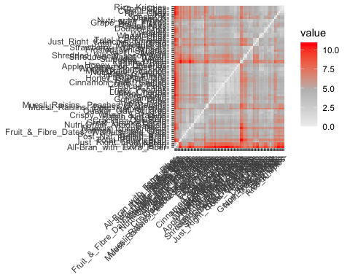

#Use the normalized data to do hierarchical clustering using the Euclidean Dist technique.  
hc1<-hclust(distance, method = "complete")  
  
#the dendogram plotting process.  
plot(hc1, hang = -1, cex = 0.6)

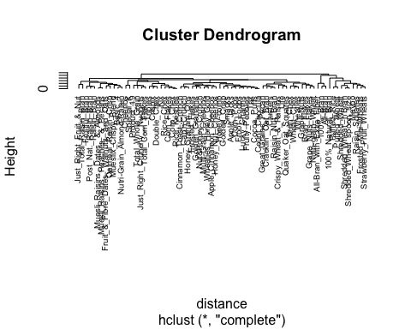

# Q1. Apply hierarchical clustering to the data using Euclidean distance to the normalized measurements. Use Agnes to compare the clustering from single linkage, complete linkage, average linkage, and Ward. Choose the best method.  
  
#Comparing hierarchical clustering with different linkages  
  
#single method - Apply hierarchical clustering  
single_hc <- agnes(distance, method = "single")  
  
# Plot the resulting dendrogram with modified appearance  
pltree(single_hc, cex=0.6, hang = -1, main = "Dendogram of agnes Single Linkage Method - Cereal Ratings")

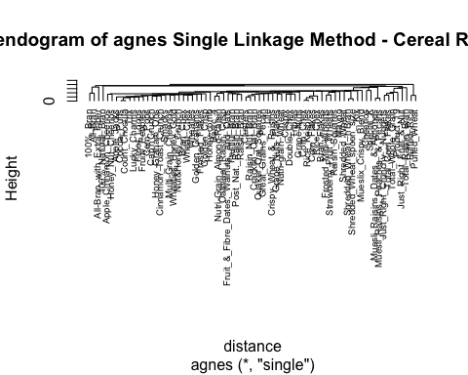

#Complete method - Apply hierarchical clustering  
complete_hc <- agnes(distance, method = "complete")  
  
# Plot the resulting dendrogram with modified appearance  
pltree(complete_hc, cex=0.6, hang = -1, main = "Dendogram of agnes Complete Linkage Method - Cereal Ratings")

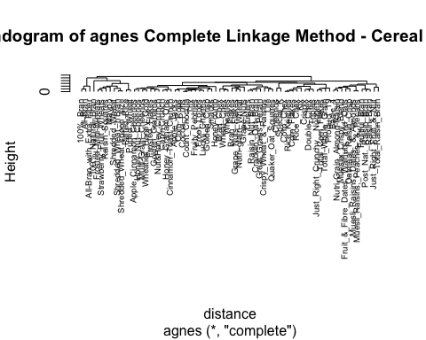

#Average method - Apply hierarchical clustering  
average_hc <- agnes(distance, method = "average")  
  
# Plot the resulting dendrogram with modified appearance  
pltree(average_hc, cex=0.6, hang = -1, main = "Dendogram of agnes Average Linkage Method - Cereal Ratings")

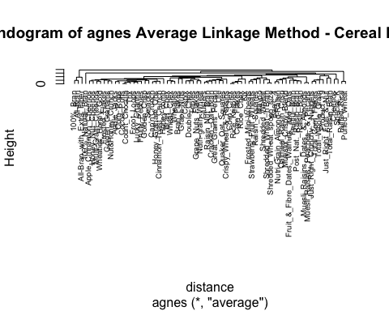

#Ward method - Apply hierarchical clustering  
ward_hc <- agnes(distance, method = "ward")  
  
# Plot the resulting dendrogram with modified appearance  
pltree(ward_hc, cex=0.6, hang = -1, main = "Dendogram of agnes Ward Linkage Method - Cereal Ratings")

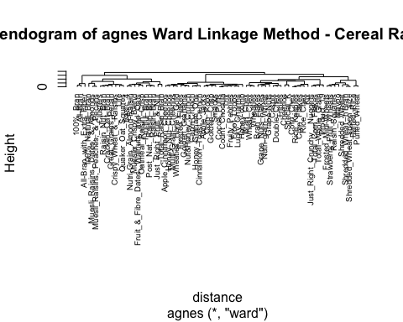

#Compare Agglomeration coefficients  
# Single  
print(single_hc$ac)

## [1] 0.6067859

#Complete  
print(complete_hc$ac)

## [1] 0.8353712

#Average  
print(average_hc$ac)

## [1] 0.7766075

# WARD Best linkage method with the coefficient of 0.9049881  
print(ward_hc$ac)

## [1] 0.9046042

# Q2. How many clusters would you choose?   
  
#Choosing the optimal number of clusters using Elbow and Silhouette methods  
  
library(cowplot)  
  
Elbow_method <- fviz_nbclust(cereals_df2, kmeans, method = "wss",k.max = 10) +labs(subtitle = "Elbow Method - K")  
  
Silhouette <- fviz_nbclust(cereals_df2, kmeans, method = "silhouette", k.max = 6) + labs(subtitle = "Silhouette Method - K")  
  
plot_grid(Elbow_method, Silhouette, nrow = 1)

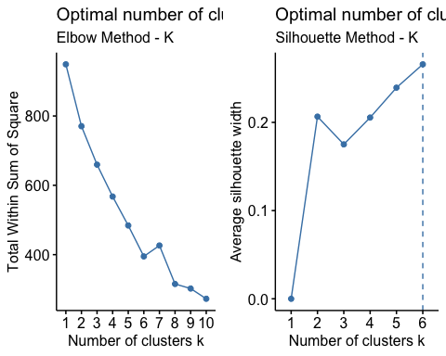

#Using the Elbow method and Siloutee stat method to determine the optimal value of k which is k = 6 where there is maximum slope  
  
  
# Plot dendrogram with 6 clusters outlined  
plot(ward_hc,   
 main = "AGNES - Ward Linkage Method using 6 Clusters Outlined",  
 xlab = "Cereal Type",  
 ylab = "Height - Dist",  
 cex.axis = 1,  
 cex = 0.50,)

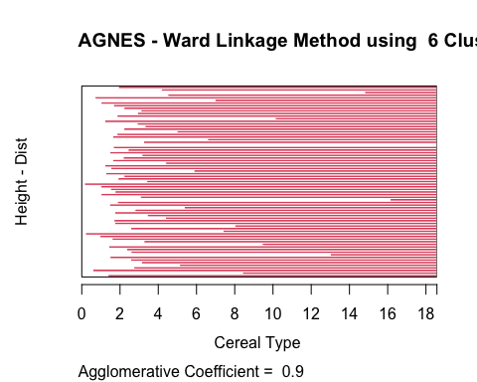

rect.hclust(ward_hc, k = 6, border = 2:7)

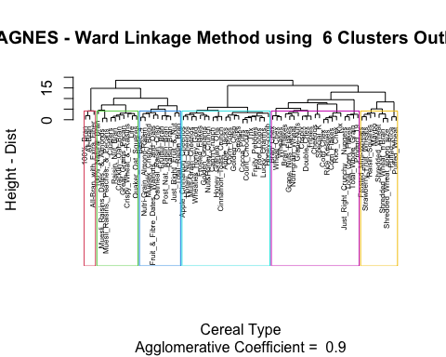

# Cut the tree into 6 clusters  
clusters1 <- cutree(ward_hc, k = 6)  
cereals_df2_6 <- as.data.frame(cbind(cereals_df2,clusters1))

fviz_cluster(list(data = cereals_df2, cluster = clusters1))

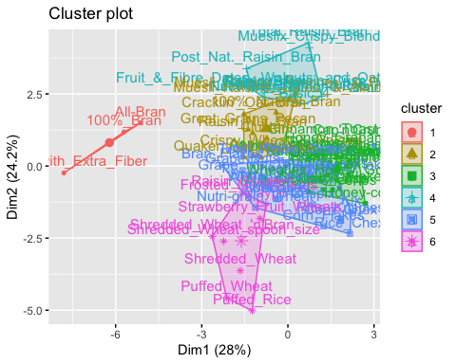

#Creating  
#For the stability of the clusters, partitioning the data into A and B  
set.seed(123)  
  
cereal_df_A <-cereals_df1 [1:55,]  
cereal_df_B <-cereals_df1 [56:74,]

#Performing Hierarchical Clustering while considering k = 6.  
single_k6 <- agnes(scale(cereal_df_A), method = "single")  
complete_k6 <- agnes(scale(cereal_df_A), method = "complete")  
average_k6 <- agnes(scale(cereal_df_A), method = "average")  
ward_k6 <- agnes(scale(cereal_df_A), method = "ward")  
  
  
cbind(single=single_k6$ac , complete=complete_k6$ac , average= average_k6$ac , ward= ward_k6$ac)

## single complete average ward  
## [1,] 0.6564842 0.8120228 0.7449303 0.8808195

pltree(ward_k6, cex = 0.6, hang = -1, main = "Dendogram of Agnes with Partitioned Data (Using Ward method)")  
  
rect.hclust(ward_k6, k = 6, border = 2:7)

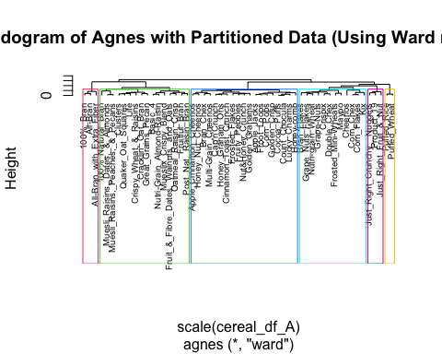

cut_2 <- cutree(ward_k6, k = 6)

#the centroids are calculated.  
Sb_result <- as.data.frame(cbind(cereal_df_A, cut_2))  
  
Sb_result[Sb_result$cut_2==1,]

## calories protein fat sodium fiber carbo sugars potass  
## 100%_Bran 70 4 1 130 10 5 6 280  
## All-Bran 70 4 1 260 9 7 5 320  
## All-Bran_with_Extra_Fiber 50 4 0 140 14 8 0 330  
## vitamins shelf weight cups rating cut_2  
## 100%_Bran 25 3 1 0.33 68.40297 1  
## All-Bran 25 3 1 0.33 59.42551 1  
## All-Bran_with_Extra_Fiber 25 3 1 0.50 93.70491 1

one_centroid <- colMeans(Sb_result[Sb_result$cut_2==1,])  
  
Sb_result[Sb_result$cut_2==2,]

## calories protein fat sodium fiber carbo  
## 100%_Natural_Bran 120 3 5 15 2.0 8.0  
## Basic_4 130 3 2 210 2.0 18.0  
## Clusters 110 3 2 140 2.0 13.0  
## Cracklin'_Oat_Bran 110 3 3 140 4.0 10.0  
## Crispy_Wheat_&_Raisins 100 2 1 140 2.0 11.0  
## Fruit_&_Fibre_Dates,_Walnuts,_and_Oats 120 3 2 160 5.0 12.0  
## Fruitful_Bran 120 3 0 240 5.0 14.0  
## Great_Grains_Pecan 120 3 3 75 3.0 13.0  
## Life 100 4 2 150 2.0 12.0  
## Muesli_Raisins,_Dates,_&_Almonds 150 4 3 95 3.0 16.0  
## Muesli_Raisins,_Peaches,_&_Pecans 150 4 3 150 3.0 16.0  
## Mueslix_Crispy_Blend 160 3 2 150 3.0 17.0  
## Nutri-Grain_Almond-Raisin 140 3 2 220 3.0 21.0  
## Oatmeal_Raisin_Crisp 130 3 2 170 1.5 13.5  
## Post_Nat._Raisin_Bran 120 3 1 200 6.0 11.0  
## Quaker_Oat_Squares 100 4 1 135 2.0 14.0  
## sugars potass vitamins shelf weight cups  
## 100%_Natural_Bran 8 135 0 3 1.00 1.00  
## Basic_4 8 100 25 3 1.33 0.75  
## Clusters 7 105 25 3 1.00 0.50  
## Cracklin'_Oat_Bran 7 160 25 3 1.00 0.50  
## Crispy_Wheat_&_Raisins 10 120 25 3 1.00 0.75  
## Fruit_&_Fibre_Dates,_Walnuts,_and_Oats 10 200 25 3 1.25 0.67  
## Fruitful_Bran 12 190 25 3 1.33 0.67  
## Great_Grains_Pecan 4 100 25 3 1.00 0.33  
## Life 6 95 25 2 1.00 0.67  
## Muesli_Raisins,_Dates,_&_Almonds 11 170 25 3 1.00 1.00  
## Muesli_Raisins,_Peaches,_&_Pecans 11 170 25 3 1.00 1.00  
## Mueslix_Crispy_Blend 13 160 25 3 1.50 0.67  
## Nutri-Grain_Almond-Raisin 7 130 25 3 1.33 0.67  
## Oatmeal_Raisin_Crisp 10 120 25 3 1.25 0.50  
## Post_Nat._Raisin_Bran 14 260 25 3 1.33 0.67  
## Quaker_Oat_Squares 6 110 25 3 1.00 0.50  
## rating cut_2  
## 100%_Natural_Bran 33.98368 2  
## Basic_4 37.03856 2  
## Clusters 40.40021 2  
## Cracklin'_Oat_Bran 40.44877 2  
## Crispy_Wheat_&_Raisins 36.17620 2  
## Fruit_&_Fibre_Dates,_Walnuts,_and_Oats 40.91705 2  
## Fruitful_Bran 41.01549 2  
## Great_Grains_Pecan 45.81172 2  
## Life 45.32807 2  
## Muesli_Raisins,_Dates,_&_Almonds 37.13686 2  
## Muesli_Raisins,_Peaches,_&_Pecans 34.13976 2  
## Mueslix_Crispy_Blend 30.31335 2  
## Nutri-Grain_Almond-Raisin 40.69232 2  
## Oatmeal_Raisin_Crisp 30.45084 2  
## Post_Nat._Raisin_Bran 37.84059 2  
## Quaker_Oat_Squares 49.51187 2

two_centroid <- colMeans(Sb_result[Sb_result$cut_2==2,])  
  
Sb_result[Sb_result$cut_2==3,]

## calories protein fat sodium fiber carbo sugars potass  
## Apple_Cinnamon_Cheerios 110 2 2 180 1.5 10.5 10 70  
## Apple_Jacks 110 2 0 125 1.0 11.0 14 30  
## Bran_Chex 90 2 1 200 4.0 15.0 6 125  
## Cap'n'Crunch 120 1 2 220 0.0 12.0 12 35  
## Cinnamon_Toast_Crunch 120 1 3 210 0.0 13.0 9 45  
## Cocoa_Puffs 110 1 1 180 0.0 12.0 13 55  
## Corn_Pops 110 1 0 90 1.0 13.0 12 20  
## Count_Chocula 110 1 1 180 0.0 12.0 13 65  
## Froot_Loops 110 2 1 125 1.0 11.0 13 30  
## Frosted_Flakes 110 1 0 200 1.0 14.0 11 25  
## Fruity_Pebbles 110 1 1 135 0.0 13.0 12 25  
## Golden_Crisp 100 2 0 45 0.0 11.0 15 40  
## Golden_Grahams 110 1 1 280 0.0 15.0 9 45  
## Honey_Graham_Ohs 120 1 2 220 1.0 12.0 11 45  
## Honey_Nut_Cheerios 110 3 1 250 1.5 11.5 10 90  
## Honey-comb 110 1 0 180 0.0 14.0 11 35  
## Lucky_Charms 110 2 1 180 0.0 12.0 12 55  
## Multi-Grain_Cheerios 100 2 1 220 2.0 15.0 6 90  
## Nut&Honey_Crunch 120 2 1 190 0.0 15.0 9 40  
## vitamins shelf weight cups rating cut_2  
## Apple_Cinnamon_Cheerios 25 1 1 0.75 29.50954 3  
## Apple_Jacks 25 2 1 1.00 33.17409 3  
## Bran_Chex 25 1 1 0.67 49.12025 3  
## Cap'n'Crunch 25 2 1 0.75 18.04285 3  
## Cinnamon_Toast_Crunch 25 2 1 0.75 19.82357 3  
## Cocoa_Puffs 25 2 1 1.00 22.73645 3  
## Corn_Pops 25 2 1 1.00 35.78279 3  
## Count_Chocula 25 2 1 1.00 22.39651 3  
## Froot_Loops 25 2 1 1.00 32.20758 3  
## Frosted_Flakes 25 1 1 0.75 31.43597 3  
## Fruity_Pebbles 25 2 1 0.75 28.02576 3  
## Golden_Crisp 25 1 1 0.88 35.25244 3  
## Golden_Grahams 25 2 1 0.75 23.80404 3  
## Honey_Graham_Ohs 25 2 1 1.00 21.87129 3  
## Honey_Nut_Cheerios 25 1 1 0.75 31.07222 3  
## Honey-comb 25 1 1 1.33 28.74241 3  
## Lucky_Charms 25 2 1 1.00 26.73451 3  
## Multi-Grain_Cheerios 25 1 1 1.00 40.10596 3  
## Nut&Honey_Crunch 25 2 1 0.67 29.92429 3

three_centroid <- colMeans(Sb_result[Sb_result$cut_2==3,])  
  
Sb_result[Sb_result$cut_2==4,]

## calories protein fat sodium fiber carbo sugars potass  
## Bran_Flakes 90 3 0 210 5 13 5 190  
## Cheerios 110 6 2 290 2 17 1 105  
## Corn_Chex 110 2 0 280 0 22 3 25  
## Corn_Flakes 100 2 0 290 1 21 2 35  
## Crispix 110 2 0 220 1 21 3 30  
## Double_Chex 100 2 0 190 1 18 5 80  
## Frosted_Mini-Wheats 100 3 0 0 3 14 7 100  
## Grape_Nuts_Flakes 100 3 1 140 3 15 5 85  
## Grape-Nuts 110 3 0 170 3 17 3 90  
## Kix 110 2 1 260 0 21 3 40  
## Maypo 100 4 1 0 0 16 3 95  
## Nutri-grain_Wheat 90 3 0 170 3 18 2 90  
## vitamins shelf weight cups rating cut_2  
## Bran_Flakes 25 3 1 0.67 53.31381 4  
## Cheerios 25 1 1 1.25 50.76500 4  
## Corn_Chex 25 1 1 1.00 41.44502 4  
## Corn_Flakes 25 1 1 1.00 45.86332 4  
## Crispix 25 3 1 1.00 46.89564 4  
## Double_Chex 25 3 1 0.75 44.33086 4  
## Frosted_Mini-Wheats 25 2 1 0.80 58.34514 4  
## Grape_Nuts_Flakes 25 3 1 0.88 52.07690 4  
## Grape-Nuts 25 3 1 0.25 53.37101 4  
## Kix 25 2 1 1.50 39.24111 4  
## Maypo 25 2 1 1.00 54.85092 4  
## Nutri-grain_Wheat 25 3 1 1.00 59.64284 4

four_centroid <- colMeans(Sb_result[Sb_result$cut_2==4,])  
  
  
centroids <- rbind(one_centroid, two_centroid, three_centroid, four_centroid)  
  
x2 <- as.data.frame(rbind(centroids[,-14], cereal_df_B))

#figuring out the Dist.  
Dist_1 <- get_dist(x2)  
Matrix_1 <- as.matrix(Dist_1)  
dataframe1 <- data.frame(data=seq(1,nrow(cereal_df_B),1), Clusters = rep(0,nrow(cereal_df_B)))  
for(i in 1:nrow(cereal_df_B))   
 {dataframe1[i,2] <- which.min(Matrix_1[i+4, 1:4])}  
dataframe1

## data Clusters  
## 1 1 1  
## 2 2 2  
## 3 3 2  
## 4 4 3  
## 5 5 3  
## 6 6 2  
## 7 7 2  
## 8 8 2  
## 9 9 3  
## 10 10 4  
## 11 11 2  
## 12 12 3  
## 13 13 2  
## 14 14 4  
## 15 15 4  
## 16 16 3  
## 17 17 4  
## 18 18 4  
## 19 19 3

cbind(cereals_df2_6$clusters1[56:74], dataframe1$Clusters)

## [,1] [,2]  
## [1,] 4 1  
## [2,] 2 2  
## [3,] 6 2  
## [4,] 5 3  
## [5,] 5 3  
## [6,] 6 2  
## [7,] 6 2  
## [8,] 6 2  
## [9,] 3 3  
## [10,] 5 4  
## [11,] 6 2  
## [12,] 5 3  
## [13,] 4 2  
## [14,] 5 4  
## [15,] 5 4  
## [16,] 3 3  
## [17,] 5 4  
## [18,] 5 4  
## [19,] 3 3

table(cereals_df2_6$clusters1[56:74] == dataframe1$Clusters)

##   
## FALSE TRUE   
## 15 4

#Since we are getting 15 FALSE and 4 TRUE, we can conclude that the model is partially stable.

#The elementary public schools would like to choose a set of cereals to include in their daily cafeterias. Every day a different cereal is offered, but all cereals should support a healthy diet. For this goal, you are requested to find a cluster of “healthy cereals.”Should the data be normalized? If not, how should they be used in the cluster analysis?  
  
#Clustering Healthy SB_Cereals.  
  
Healthy_SB_Cereals <- cereals  
  
#omitting the empty observations  
Healthy_SB_Cereals_NA <- na.omit(Healthy_SB_Cereals)  
  
#binding the clusters  
clust <- cbind(Healthy_SB_Cereals_NA, clusters1)  
  
clust[clust$clusters1==1,]

## name mfr type calories protein  
## 100%_Bran 100%_Bran N C 70 4  
## All-Bran All-Bran K C 70 4  
## All-Bran_with_Extra_Fiber All-Bran_with_Extra_Fiber K C 50 4  
## fat sodium fiber carbo sugars potass vitamins shelf  
## 100%_Bran 1 130 10 5 6 280 25 3  
## All-Bran 1 260 9 7 5 320 25 3  
## All-Bran_with_Extra_Fiber 0 140 14 8 0 330 25 3  
## weight cups rating clusters1  
## 100%_Bran 1 0.33 68.40297 1  
## All-Bran 1 0.33 59.42551 1  
## All-Bran_with_Extra_Fiber 1 0.50 93.70491 1

clust[clust$clusters1==2,]

## name mfr type  
## 100%_Natural_Bran 100%_Natural_Bran Q C  
## Clusters Clusters G C  
## Cracklin'_Oat_Bran Cracklin'_Oat_Bran K C  
## Crispy_Wheat_&_Raisins Crispy_Wheat_&_Raisins G C  
## Great_Grains_Pecan Great_Grains_Pecan P C  
## Life Life Q C  
## Muesli_Raisins,_Dates,_&_Almonds Muesli_Raisins,_Dates,_&_Almonds R C  
## Muesli_Raisins,_Peaches,_&_Pecans Muesli_Raisins,_Peaches,_&_Pecans R C  
## Quaker_Oat_Squares Quaker_Oat_Squares Q C  
## Raisin_Nut_Bran Raisin_Nut_Bran G C  
## calories protein fat sodium fiber carbo  
## 100%_Natural_Bran 120 3 5 15 2.0 8.0  
## Clusters 110 3 2 140 2.0 13.0  
## Cracklin'_Oat_Bran 110 3 3 140 4.0 10.0  
## Crispy_Wheat_&_Raisins 100 2 1 140 2.0 11.0  
## Great_Grains_Pecan 120 3 3 75 3.0 13.0  
## Life 100 4 2 150 2.0 12.0  
## Muesli_Raisins,_Dates,_&_Almonds 150 4 3 95 3.0 16.0  
## Muesli_Raisins,_Peaches,_&_Pecans 150 4 3 150 3.0 16.0  
## Quaker_Oat_Squares 100 4 1 135 2.0 14.0  
## Raisin_Nut_Bran 100 3 2 140 2.5 10.5  
## sugars potass vitamins shelf weight cups  
## 100%_Natural_Bran 8 135 0 3 1 1.00  
## Clusters 7 105 25 3 1 0.50  
## Cracklin'_Oat_Bran 7 160 25 3 1 0.50  
## Crispy_Wheat_&_Raisins 10 120 25 3 1 0.75  
## Great_Grains_Pecan 4 100 25 3 1 0.33  
## Life 6 95 25 2 1 0.67  
## Muesli_Raisins,_Dates,_&_Almonds 11 170 25 3 1 1.00  
## Muesli_Raisins,_Peaches,_&_Pecans 11 170 25 3 1 1.00  
## Quaker_Oat_Squares 6 110 25 3 1 0.50  
## Raisin_Nut_Bran 8 140 25 3 1 0.50  
## rating clusters1  
## 100%_Natural_Bran 33.98368 2  
## Clusters 40.40021 2  
## Cracklin'_Oat_Bran 40.44877 2  
## Crispy_Wheat_&_Raisins 36.17620 2  
## Great_Grains_Pecan 45.81172 2  
## Life 45.32807 2  
## Muesli_Raisins,_Dates,_&_Almonds 37.13686 2  
## Muesli_Raisins,_Peaches,_&_Pecans 34.13976 2  
## Quaker_Oat_Squares 49.51187 2  
## Raisin_Nut_Bran 39.70340 2

clust[clust$clusters1==3,]

## name mfr type calories protein fat  
## Apple_Cinnamon_Cheerios Apple_Cinnamon_Cheerios G C 110 2 2  
## Apple_Jacks Apple_Jacks K C 110 2 0  
## Cap'n'Crunch Cap'n'Crunch Q C 120 1 2  
## Cinnamon_Toast_Crunch Cinnamon_Toast_Crunch G C 120 1 3  
## Cocoa_Puffs Cocoa_Puffs G C 110 1 1  
## Corn_Pops Corn_Pops K C 110 1 0  
## Count_Chocula Count_Chocula G C 110 1 1  
## Froot_Loops Froot_Loops K C 110 2 1  
## Frosted_Flakes Frosted_Flakes K C 110 1 0  
## Fruity_Pebbles Fruity_Pebbles P C 110 1 1  
## Golden_Crisp Golden_Crisp P C 100 2 0  
## Golden_Grahams Golden_Grahams G C 110 1 1  
## Honey_Graham_Ohs Honey_Graham_Ohs Q C 120 1 2  
## Honey_Nut_Cheerios Honey_Nut_Cheerios G C 110 3 1  
## Honey-comb Honey-comb P C 110 1 0  
## Lucky_Charms Lucky_Charms G C 110 2 1  
## Multi-Grain_Cheerios Multi-Grain_Cheerios G C 100 2 1  
## Nut&Honey_Crunch Nut&Honey_Crunch K C 120 2 1  
## Smacks Smacks K C 110 2 1  
## Trix Trix G C 110 1 1  
## Wheaties_Honey_Gold Wheaties_Honey_Gold G C 110 2 1  
## sodium fiber carbo sugars potass vitamins shelf weight  
## Apple_Cinnamon_Cheerios 180 1.5 10.5 10 70 25 1 1  
## Apple_Jacks 125 1.0 11.0 14 30 25 2 1  
## Cap'n'Crunch 220 0.0 12.0 12 35 25 2 1  
## Cinnamon_Toast_Crunch 210 0.0 13.0 9 45 25 2 1  
## Cocoa_Puffs 180 0.0 12.0 13 55 25 2 1  
## Corn_Pops 90 1.0 13.0 12 20 25 2 1  
## Count_Chocula 180 0.0 12.0 13 65 25 2 1  
## Froot_Loops 125 1.0 11.0 13 30 25 2 1  
## Frosted_Flakes 200 1.0 14.0 11 25 25 1 1  
## Fruity_Pebbles 135 0.0 13.0 12 25 25 2 1  
## Golden_Crisp 45 0.0 11.0 15 40 25 1 1  
## Golden_Grahams 280 0.0 15.0 9 45 25 2 1  
## Honey_Graham_Ohs 220 1.0 12.0 11 45 25 2 1  
## Honey_Nut_Cheerios 250 1.5 11.5 10 90 25 1 1  
## Honey-comb 180 0.0 14.0 11 35 25 1 1  
## Lucky_Charms 180 0.0 12.0 12 55 25 2 1  
## Multi-Grain_Cheerios 220 2.0 15.0 6 90 25 1 1  
## Nut&Honey_Crunch 190 0.0 15.0 9 40 25 2 1  
## Smacks 70 1.0 9.0 15 40 25 2 1  
## Trix 140 0.0 13.0 12 25 25 2 1  
## Wheaties_Honey_Gold 200 1.0 16.0 8 60 25 1 1  
## cups rating clusters1  
## Apple_Cinnamon_Cheerios 0.75 29.50954 3  
## Apple_Jacks 1.00 33.17409 3  
## Cap'n'Crunch 0.75 18.04285 3  
## Cinnamon_Toast_Crunch 0.75 19.82357 3  
## Cocoa_Puffs 1.00 22.73645 3  
## Corn_Pops 1.00 35.78279 3  
## Count_Chocula 1.00 22.39651 3  
## Froot_Loops 1.00 32.20758 3  
## Frosted_Flakes 0.75 31.43597 3  
## Fruity_Pebbles 0.75 28.02576 3  
## Golden_Crisp 0.88 35.25244 3  
## Golden_Grahams 0.75 23.80404 3  
## Honey_Graham_Ohs 1.00 21.87129 3  
## Honey_Nut_Cheerios 0.75 31.07222 3  
## Honey-comb 1.33 28.74241 3  
## Lucky_Charms 1.00 26.73451 3  
## Multi-Grain_Cheerios 1.00 40.10596 3  
## Nut&Honey_Crunch 0.67 29.92429 3  
## Smacks 0.75 31.23005 3  
## Trix 1.00 27.75330 3  
## Wheaties_Honey_Gold 0.75 36.18756 3

clust[clust$clusters1==4,]

## name  
## Basic_4 Basic_4  
## Fruit_&_Fibre_Dates,_Walnuts,_and_Oats Fruit_&_Fibre_Dates,_Walnuts,_and_Oats  
## Fruitful_Bran Fruitful_Bran  
## Just_Right_Fruit_&_Nut Just_Right_Fruit_&_Nut  
## Mueslix_Crispy_Blend Mueslix_Crispy_Blend  
## Nutri-Grain_Almond-Raisin Nutri-Grain_Almond-Raisin  
## Oatmeal_Raisin_Crisp Oatmeal_Raisin_Crisp  
## Post_Nat._Raisin_Bran Post_Nat._Raisin_Bran  
## Raisin_Bran Raisin_Bran  
## Total_Raisin_Bran Total_Raisin_Bran  
## mfr type calories protein fat sodium  
## Basic_4 G C 130 3 2 210  
## Fruit_&_Fibre_Dates,_Walnuts,_and_Oats P C 120 3 2 160  
## Fruitful_Bran K C 120 3 0 240  
## Just_Right_Fruit_&_Nut K C 140 3 1 170  
## Mueslix_Crispy_Blend K C 160 3 2 150  
## Nutri-Grain_Almond-Raisin K C 140 3 2 220  
## Oatmeal_Raisin_Crisp G C 130 3 2 170  
## Post_Nat._Raisin_Bran P C 120 3 1 200  
## Raisin_Bran K C 120 3 1 210  
## Total_Raisin_Bran G C 140 3 1 190  
## fiber carbo sugars potass vitamins shelf  
## Basic_4 2.0 18.0 8 100 25 3  
## Fruit_&_Fibre_Dates,_Walnuts,_and_Oats 5.0 12.0 10 200 25 3  
## Fruitful_Bran 5.0 14.0 12 190 25 3  
## Just_Right_Fruit_&_Nut 2.0 20.0 9 95 100 3  
## Mueslix_Crispy_Blend 3.0 17.0 13 160 25 3  
## Nutri-Grain_Almond-Raisin 3.0 21.0 7 130 25 3  
## Oatmeal_Raisin_Crisp 1.5 13.5 10 120 25 3  
## Post_Nat._Raisin_Bran 6.0 11.0 14 260 25 3  
## Raisin_Bran 5.0 14.0 12 240 25 2  
## Total_Raisin_Bran 4.0 15.0 14 230 100 3  
## weight cups rating clusters1  
## Basic_4 1.33 0.75 37.03856 4  
## Fruit_&_Fibre_Dates,_Walnuts,_and_Oats 1.25 0.67 40.91705 4  
## Fruitful_Bran 1.33 0.67 41.01549 4  
## Just_Right_Fruit_&_Nut 1.30 0.75 36.47151 4  
## Mueslix_Crispy_Blend 1.50 0.67 30.31335 4  
## Nutri-Grain_Almond-Raisin 1.33 0.67 40.69232 4  
## Oatmeal_Raisin_Crisp 1.25 0.50 30.45084 4  
## Post_Nat._Raisin_Bran 1.33 0.67 37.84059 4  
## Raisin_Bran 1.33 0.75 39.25920 4  
## Total_Raisin_Bran 1.50 1.00 28.59278 4

#Mean ratings are used to select the best cluster.  
mean(clust[clust$clusters1==1,"rating"])

## [1] 73.84446

mean(clust[clust$clusters1==2,"rating"])

## [1] 40.26405

mean(clust[clust$clusters1==3,"rating"])

## [1] 28.84825

mean(clust[clust$clusters1==4,"rating"])

## [1] 36.25917

# Based on the mean ratings for each cluster, it seems that cluster 1 has the highest mean rating at 73.8, Therefore, Group 1 may be considered of as the cluster for a healthy diet.